ASR – CBM Estimator per shipment per container (M3)
Date: 2012.08.06

Assumption:
- 1 container 1 shipment
- 1 shipments can have single or multiple TOs
- Shipment volume estimation by M3 only
- User pre-defines Maximum capacity of M3 per Container.
i.e. range from 30 – 40 m3

- SKU with minimum Carton M3 setup is required. Loose unit M3 is not applicable.
- SKU with full STD pallet indicator, to apply the Max Height of the pallet. ( = full capacity of M3 per pallet) -- not yet apply to WMS estimator (as of 2012.09.05)

- M3 calculation:
  - Dimension based on SKU Master setup.
- SKU with pallet dimension (QtyPerPallet <> 0)
    - get full pallet M3 + loose Cartons M3
    - if with STD Pallet indicator ( do not allow Pallet top up, system to apply maximum m3 per pallet, pallet height = 1.8)
- SKU without Pallet dimension, i.e. Carton dimension only
- get loose Cartons M3

- SKU without Pallet/Carton dimension, possible liquids
- get loose EACH M3

Scenario to build up 1 container:
- Splits by TO Lines
- combination of multiple TOs
- combination of TOs and splited TO lines

Screen Prototype:
Screen: Estimation per container

Retrieval Parameters:
Retrieve
From TO Date: | To TO Date:
From TO#: | To TO#:
Country :
 | User input max m3 per container

Container Max M3:
Print

Source: | ⬅  ➔  Range Lines: | M3 Estimator:  Total m3 must not exceed Max M3
  TO List
  + 0000012000 Ctry MOT
  - 0000012001
  Line 1 SKU Batch# Qty UOM Source
  Line 2
  Line 3
  Line 4
  + 00000120002
  + ….
  TO List contains:
  SKU Qty #Pallets #Cartons #Loose M3
 |  | Total M3: _______

Function:
- Feature allows drag and drop TOs or TO lines from source to M3 estimator
- Feature allows input “range of lines” per TO to drag to M3 estimator
- M3 Estimator:
- Group order qty from dragged lines by SKU,
- Get # of Pallets / Cartons / Loose Units
- Calculate the estimated M3 SKU

Validation:
Total estimated M3 should not greater than defined Container Max M3.
Flag out SKU without Pallet or Carton dimension setup
WMS Estimator Screen shot:
Date: 2012.09.05

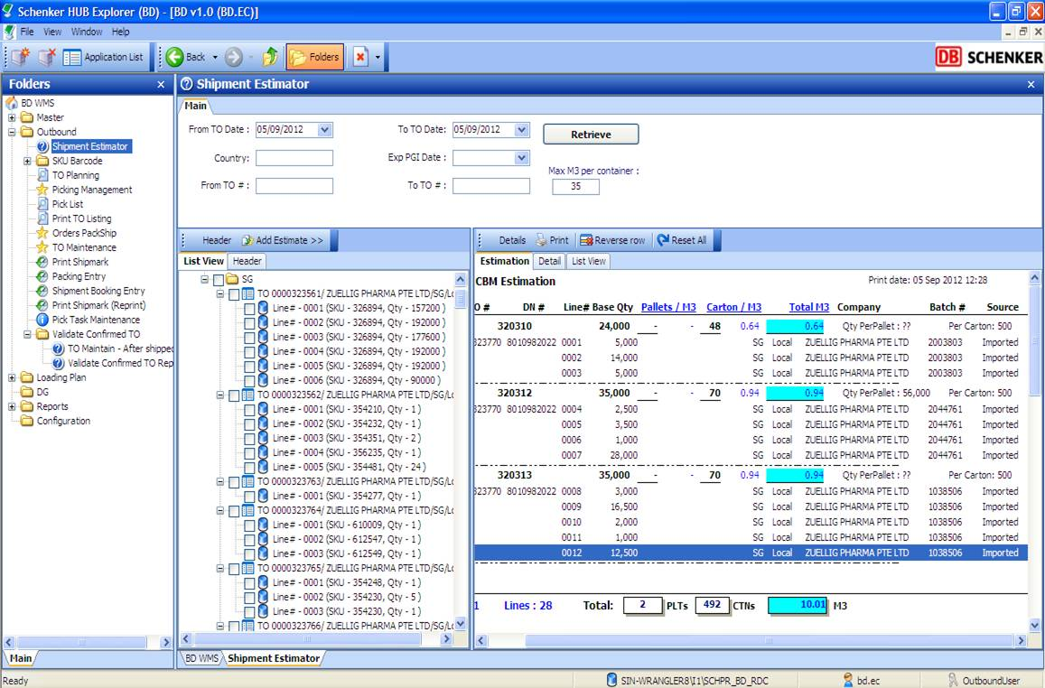
Selection criteia
Source TO# range for estimation
Estimated M3 grouped by SKU of selected TO/Lines

Steps:
- Input selection criteria:
  - input range of TO# Date ( TO uploaded date), From TO Date and To TO Date:
  - Input Country OR
  - Input TO # range ( From TO#: and To TO#: )

- Click Retrieve to retrieve expected TO for estimation
- Select TO/Line# from Source TO list view listing (Left column)
- Click button [Add estimate], system will auto calculate and summaries the estimated m3 at ‘estimator column on the right.
- Click [Print] to print the estimated TO list for reference.

Other function button:
[Reverse Row] – To reverse the calculated estimate m3 to source list from Estimation tab.

[Reset all] – to reset all selected TO estimation.
Sample print out:

